Walk 16 Pencombe
Last walked in July 2017

Description. An 8 km (5 mile) strenuous walk on minor roads and tracks and across farmers fields.
Start. Explorer Map 202 Grid 600528. Pencombe church.
Direction from Whitecross roundabout (Turn milometer to zero). Take the A4110 Canon Pyon (Three Elms road) for 1 mile and TR at the traffic lights onto the A4103 Worcester (Roman road). At the second roundabout, after 3.2 miles, TL towards Bodenham. At 9.5 miles at the T-junction TR onto the A417 to Gloucester. At 10.5 miles TL and go along a minor road to Pencombe. At 13.7 miles park in Pencombe Parish Hall car park on the L, just passed Pencombe church.

1. Pencombe Church. St Johns church is a very ancient and remarkable building in the Norman style. The tower (of stone) was rebuilt in 1840, and contains 3 bells. It has nave, a chancel, apse, porch, an ancient font, and three modern tablets. The church was rebuilt in 1865. With your back to the Parish Hall. TR and walk back along the road and past the church, which is on your R. Just past the church you bear R onto the road to Risbury, and go passed the village green on your L hand side that contains a monument. The road bends to the R and continues up a gradual hill. When the road bends to the R again, (on the L is a house called Hillside and on the R is a white house called ‘Old Crosses’) you TL and go through a rusty metal gate into F1. Bear diagonally R and cross the field, aiming to the R of a water tank on top of a tower that can be seen on the distant horizon. Cross over an stile (that may no longer exist), into F2, the stile should be near to a large pond and a corrugated iron roofed building. TR, walk a short distance and then bear off to the L, to pass to the R of the corrugated iron roofed building, and to cross over a stile into F3. Go straight across this field and over another stile into F4. Turn diagonally R and head up hill to reach the field corner and go through a gated gap in the hedge onto a road.

2. Road. TR and walk along the road. At the fork in the road you bear L towards Risbury. You pass by Great Hegdon Farm on your R and continue along the road to TR at a communication pylon, and continue along the enclosed bridleway to Little Hegdon. When you reach Little Hegdon you continue in the same direction along an enclosed grassy track that’s to the L of the farm, and at the end of the track you TL through a gate into F5. Keep to the hedge on your R, and after a short distance your route continues along an enclosed farm track. Just as the track starts to bend to the R, TL and go through a small wooden gate into F6, then bear slightly R to cross the narrow field to go through a waymarked metal gate in the field corner and into F7.

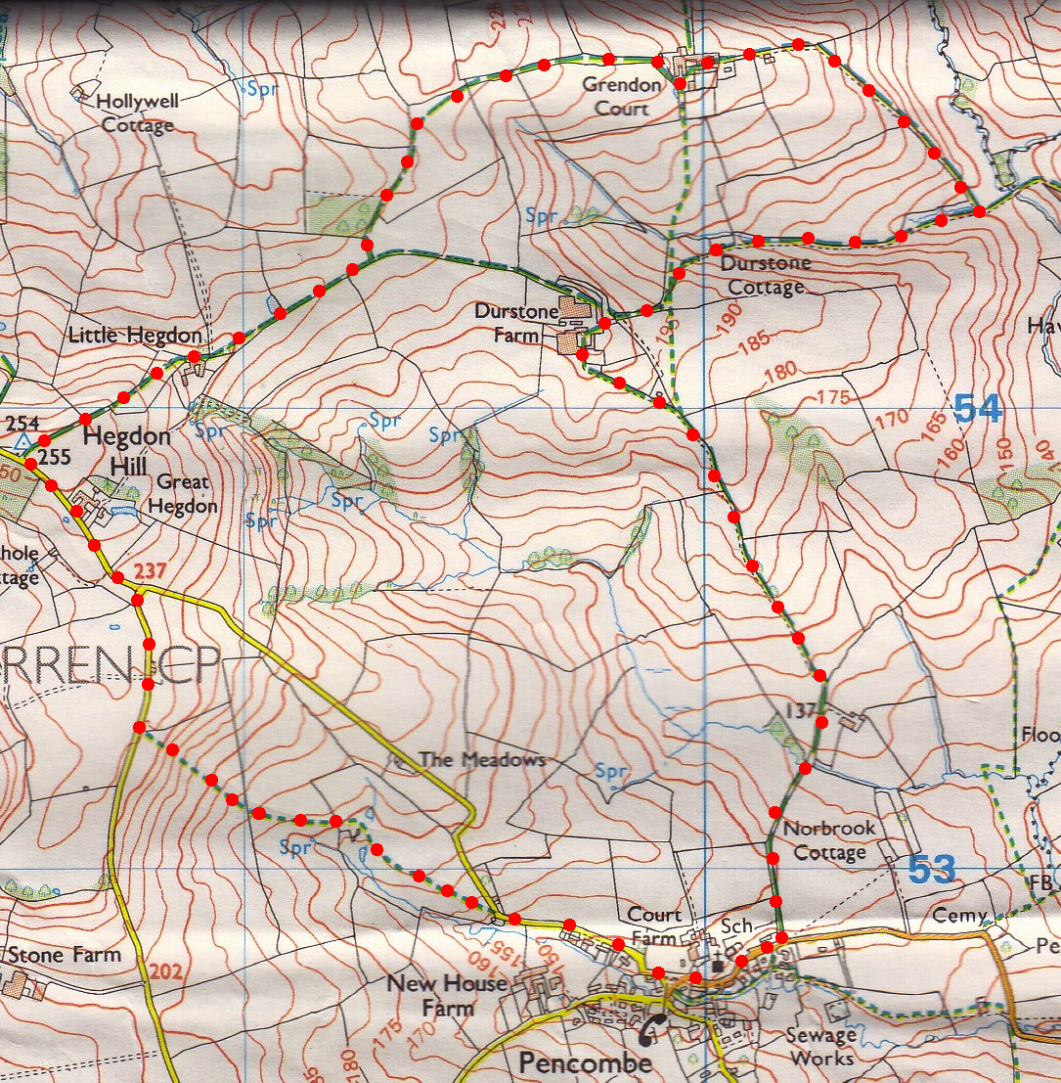
3. Metal Gate. Walk up the middle of the field and aim for the top R hand corner to go through a metal gate onto a farm track. Continue in the same direction along an enclosed farm track and onto Grendon Court Farm. Go through the farms courtyard, keeping in the same direction, to meet up with a tarmac drive/road. The tarmac drive continues down to the bottom of the hill, when you get to the T-junction (end of the tarmac) you TR and cross over a cattle grid to continue along a wide farm track. As you walk along the track you go passed Grendon Lair cottages on your R and then continue up hill to Durstone Farm.
3

4. Durstone Farm. Go through the farmyard and follow the track as it bears to the L. Cross over a cattle grid to leave the farm and continue down a wide farm track. Keep to the track for about 1¹/₂ km to reach the road at Pencombe. TR and walk to the car.
4
3
1
2

